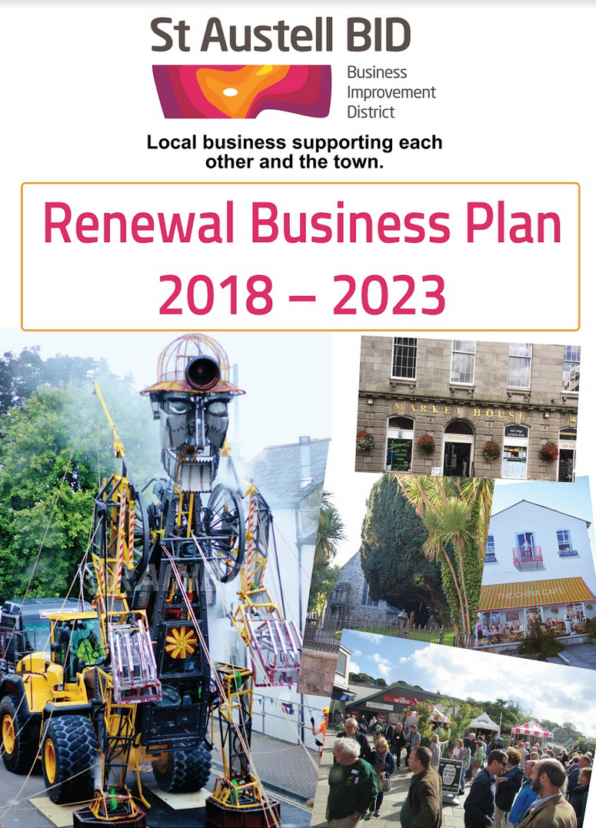

5th October 2017

St Austell BID Launches New Business Plan for the next 5 years.
St Austell Business Improvement District (BID) has launched its new Business Plan for the next five years outlining how it intends to continue the journey of improving St Austell Town Centre by making it more attractive, accessible, safer, better promoted and more vibrant.
The BID, which is run by a not for profit company with a Board comprising business people from across the town has been delivering projects and services since 2013.
Amongst its achievements, the BID has provided regular security patrols, set up the successful storenet radio system, helped the town achieve Gold in South West in Bloom through funding hanging baskets and planting, created a new website, published and circulated 120,000 town guides and organised the Christmas programme and lights and contributed to a range of other events each year. These are all initiatives which will not continue unless the BID is re-elected.
Footfall counts demonstrate that St Austell’s prospects have improved with 10% more visitors in town now than when the BID first started in April 2013.
‘The BID has been great for our business. The town promotion project alone has brought in new customers and I am really impressed with the way the town is looking I really like what the BID has done about additional security. Without the BID, we wouldn’t have a business led organisation that is forward thinking and specifically looking after our interests; I believe that would be detrimental both to the town and my business. In fact without the BID my business would have had to relocate 18 months ago.’ Rachael Hunt. Sew & Fabric
A recent consultation of businesses who fund the BID via a levy on the rateable value of their premises, indicated positive support in the BID continuing with 82% saying that they would support a second term. The new business plan has been shaped by the businesses who gave their feedback during the summer consultation.
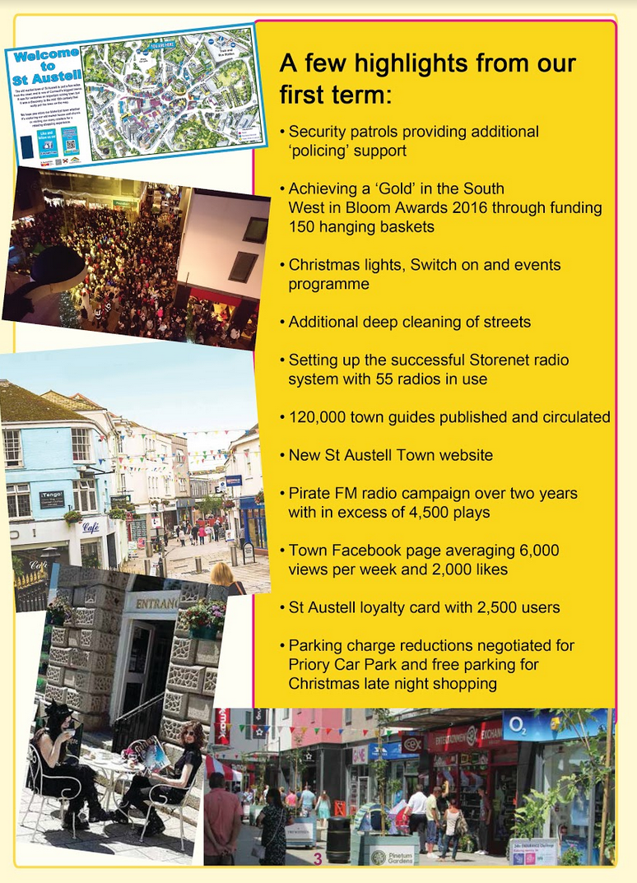
Under BID legislation, a BID can only continue for five years before a new business plan needs to be published and a ballot held where businesses vote ‘yes’ or ‘no’ to the BID. If the majority of businesses by number and rateable value, vote in favour of the proposal, the BID will go ahead and apply to all. It is just like a referendum and the majority view will prevail. Those businesses entitled to vote, circa 200 in the town, should have received a copy of the business plan in the post.

‘The St Austell BID has been very effective in making improvements to the appearance of the town; these have been agreed and driven by the business community. Cleaner streets and the wonderful flowers in the summer have all contributed to increased footfall. By working together we can make St Austell an even better destination.’ Tim Atkins. Stephens Scown LLP
St Austell’s BID Manager, Annette Miller encourages businesses to get in touch with their enquiries or alternatively attend the BID open event on Thursday 19th October between 10am and 6pm at Burton House to meet members of the BID Team.
If the BID is voted in, funds of circa £90K per year will be generated each year for five years but that is not the only source of income. Ahead of the ballot, the BID team have already secured 20% of additional funds from voluntary contributions, money that will be lost to the town centre if the BID doesn’t proceed.
‘Having recently taken on the position as Manager of the Weatherspoons here in St Austell I have had the opportunity to understand more fully the great work the BID is doing in the town. I am enthusiastic by the projects that have been delivered so far and the potential to do more over the next five years; it is clear that collectively we need to up the ante with tackling anti-social behaviour. I have now become a Director on the Board and am looking forward to being part of the action supporting the town. Aaron Niles. Wetherspoons
The ballot is organised independently by Cornwall Council and ballot papers will be sent out to circa 200 voters on 6th November. Business owners have until 5pm on Thursday 7th December to cast their vote by post or by returning their ballot paper in person to Cornwall Council’s Offices on Penwinnick Road.

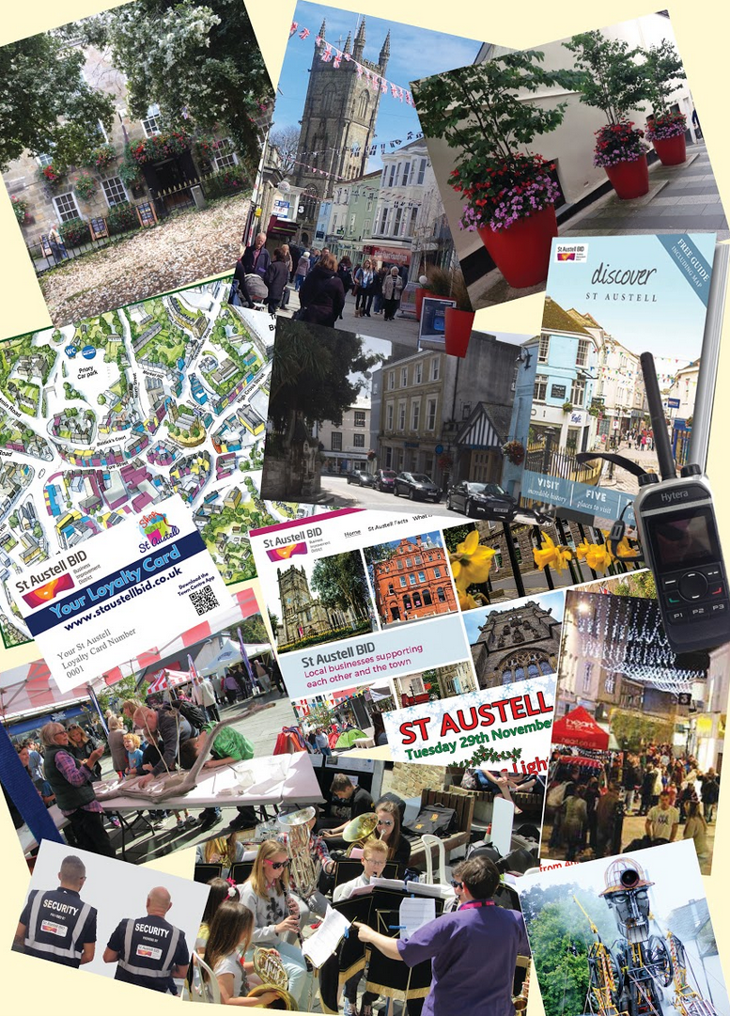
To find out more on what the BID has achieved and to read testimonials from businesses that support the BID, go to http://www.staustellbid.co.uk/help-us-shape-future/

For further information, contact Annette Miller, BID Manager on 01726 63595 or 07794 910558 or email staustellbid@gmail.com

