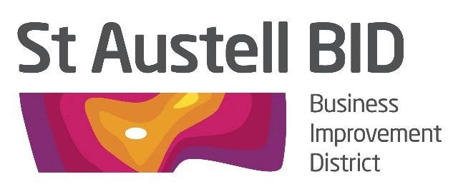

BOARD MEETING

Tuesday 1st October 2019, 5.30pm
White Hart Hotel

AGENDA

- Welcome and Apologies RH

- Minutes of Previous Meeting (1st October) RH

- Financial Update GB

- BID Managers Roundup AM
- Coastal Communities – SABEF Update RH
- Christmas AM/DL
- Training & Business Development AC/KF
- Feedback from Meetings ALL
- AOB

