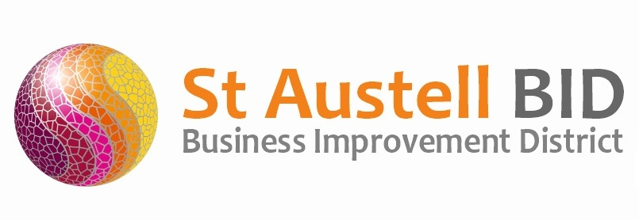
St Austell BID Board Meeting
Minutes of the meeting held on 11th January 2022.

Present: Dale Lovatt (DL), Martin Davies (MD), Bill Holland (BH), Roberto Cubbedu (RC), Martin Davis (MD), Cllr Tom French (TF), Neil Woodward (NW),
Zoom: Allan Clare
Apologies: Sean Marshall, Gillian Mullany, Sean Mitchell & Piers Thompson
In attendance: Annette Miller (AM).
- Welcome & Apologies: DL Welcomed everyone to the meeting.

- Minutes of Previous Meeting: The minutes of the board meeting held on the 2nd November 2022 were reviewed and approved.

- Finance: Monthly update provided by AM.
  - Income received during the month - £7,000 from levy collection and a £1,000 grant towards wardens/security from Cornwall Council.
  - Expenditure this month included the following costs: Administration, cost of Christmas events, town support including wardens & marketing/publicity.

- St Austell Revitalisation Partnership: The most recent partnership meeting was on the 21st December 2021, via Teams. The focus of this meeting was primarily for the newly appointed Regeneration Officer (Mr Bill McCardle) to introduce himself to the group. The official start date for Bills appointment with the Town Council is the 4th January 2022, but he has already made a great start by reviewing various previous documents and plans and has also engaged with many organisations including BID. David Pooley (Town Council Clerk) has had the procurement strategy approved by the Town Council and is now able to start on the procurement exercise along with Bill McCardle. David and Bill have already made a start on the draft specification, which will be consulted on within the Partnership at the next meeting. Approval for the final framework will be sought from the Town Council and Revitalisation Partnership in the coming weeks. With Cornwall Council facing budget cutbacks reassurance was sought and confirmed that the allocated ‘Vitality Funding’ for this work was secure and with the Town Council. – Next meeting due on the 20th January 2022.

- BID Managers Roundup: Christmas was well received. We were able to put on an enhanced programme this year thanks to the ‘Welcome Back Funding’ we were granted from Cornwall Development Company, although it has been a long and drawn-out process to achieve the funding approval. The change from late night shopping Tuesdays to the Saturday daytime family events proved popular with businesses and the public. The balance of our WBF has been allocated to be used to help increase footfall throughout January to March and to support events throughout these months. The town centre has also been allocated funding for further events to the sum of £10,000. The Hall for Cornwall were the successful bidder of the Cornwall Council tender and have appointed Prodigal UGP locally to manage 3 town centre events, to be held in February and March. We have ensured that Holy Trinity Church and the Market House have been involved in these events. New posters and banners will be installed this month to help promote the town.

- Meetings/AOB: AM & DL As we start to plan for BIDs re-election campaign, we will be asking Mel Richardson, a BID consultant to provide us with a quote to assist us with the campaign. AM to email the proposal to all Directors.

DL: St Austell BID is one of only 2 South-West BIDs to have board meetings as frequently as every month. Knowing how busy Directors are with their primary roles I would like to suggest that we reduce the frequency of the board meetings to 4 a year. The alternative approach proposed is to communicate more often via email and as such afford greater flexibility to be able to adapt more quickly to upcoming opportunities. Approval for anything that would deviate from the approved budget would be asked for via email and not restricted to the first Tuesday of every month as it is now. A vote took place, and all Directors were in favour of this proposal.

TF: Wished to pass on how impressed the Town Council Councillors were with how well the security patrols are being received by the public. And also, thanks to be passed to the BID for the enhanced Christmas events.

BH: Attended a Safer St Austell meeting, It was discussed at the meeting how the implementation of security patrols, storenet radio scheme and the DISC app have all played a massive role in managing the low levels of ASB within the town centre.

Meeting closed 18.47
Next meeting 11th April 2022 at 17.30
Burton House

