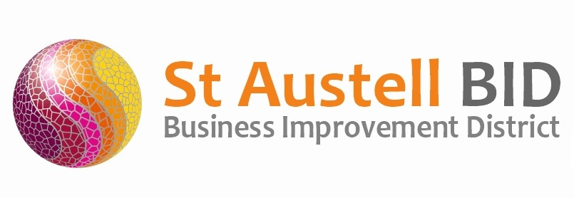
St Austell BID Board Meeting
Minutes of the meeting held on 12th July 2022, 17:30.

Present: Dale Lovatt (DL), Martin Davies (MD), Bill Holland (BH), Sean Marshall (SM), Roberto Cubbedu (RC)
Apologies: Allan Clare (AC), Sean Mitchell (SMI), Neil Woodward (NW), Cllr Tom French (TF), Gillian Mullany (GM), Piers Thomson (PT), David Rescorla (DR)
- Welcome & Apologies: DL Welcomed everyone to the meeting, whilst noting that attendance is low. There being no key decisions to be made the meeting continued.

- Minutes of Previous Meeting: The minutes of the board meeting held on the 11th April 2022 were reviewed and approved.

- Finance: Monthly update provided by DL.
  - Income received during the quarter amounted to £80,926.99 which consists of £64,250 Levy & White River Contribution, £15,725 Grant funding from the Town Council, £950.63 in voluntary contributions and £1.36 in bank interest.
  - Expenditure this quarter totalled £38,977.91 consisting of £26,779.79 in expenditure relating to the BID themes and a further £12,198.12 in administration/management costs.

- Renewal (DL): Mel Richardson continues to manage the renewal process, we are currently working on the consultation document, this will be finalised after Directors have had the opportunity to review it. We anticipate this will be send out on the 5th August. Once we have insight into member opinions and feedback, the business plan will start to be drafted taking into consideration the views of businesses and what they think we should prioritise in the next 5-year term. The business plan will also be sent to Directors to review before finalising and distributing.

- BID Managers Roundup (DL on behalf of AM):

Town news: Judging will be taking place on the 2nd & 3rd August for the RHS South West in Bloom and also the RHS Britain in Bloom. A portfolio of the town including the planting schemes and community engagement has been produced and printed.

The hanging baskets are now installed throughout the town, my thanks to Chris at Hays Nurseries for organising the fantastic scheme and also to those that helped put them up, early on a Sunday morning.

We have a range of events that BID is either co-ordinating or supporting. These include: Cornwall Pride on the 9th July, Performing Arts Show on the 16th July, Purple Day on the 23rd July, All the Fun of the Fair throughout the summer holidays (1st, 8th and 15th August), Truro Road Park Fun Day on the 29th August, Garden Festival on the 3rd September. If anyone would be able to volunteer some time on any of the events, it would be greatly appreciated.

Funding: We continue to wait patiently to receive reimbursement from Cornwall Councils Welcome Back Fund, the last update was that we should hear something by the end of August. The reimbursement is in the region of £28,000

Marketing: Lots of our A1 advertising boards have been vandalised and so we have now had to bring them all in. We are looking into some more robust alternatives.

Security: We continue to fund 50 hours per week security patrolling throughout the town, much of the work the team are engaged in is welfare/safeguarding issues. We were due to reduce the frequency of the patrols due to lack of funding, however the Town Council have agreed to match fund in order to continue at 50 hours per week. It is recognised how the patrols have a positive impact on reducing ASB.

BID security has also dealt with numerous break ins at the General Wolfe, School Children were found in the derelict Clintons and Burtons buildings, there have also been a few incidences of shoplifting and substance abuse.

Monthly updates are held with the Town Council, Police and ASB case worker. Our crime rate for the town is down 31% and we now fluctuate between 5th and 6th on the ASB rates for Cornwall. This is an achievement as we were in the worst spot (at number 1) for many years.

- St Austell Revitalisation Partnership: Please see below link to the minutes of the most recent Revitalisation Partnership meeting (28/06/22)
https://www.staustell-tc.gov.uk/_UserFiles/Files/_Minutes/143220-June_-_Minutes.pdf

- Meetings/AOB: Nothing to report

Meeting closed 18:33
Next meeting (AGM & Board Meeting)
Tuesday 06th September 2022 at 17:30
White Hart Hotel

